The gender pay gap

**Data from 6 April 2023 to 5 April 2024**

We face similar challenges to peers across the financial services industry with lower representation of women in highly compensated investment and senior management positions.

While we are implementing various initiatives to narrow the gender pay gap, during the reporting year, our hourly wage gap increased by 0.08% across Canaccord Genuity Wealth Limited (CGWL).

In 2023/24, we increased our male workforce by 21% and our female workforce by 19.8%; as of 5 April 2024, CGWL employs 253 men and 176 women.

However, there are some important factors contributing to our gender pay gap. More men were recruited for client-facing roles at our central London office (where pay is higher) than women, and across the business 57% of women work outside of London compared to 33% of men. For similar roles within the same location, the gender pay gap is minimal; for instance, in Blackpool's client services, the mean hourly pay gap is 2.59%.

Going above and beyond for our colleagues

At CGWL, we consistently aim to enhance all areas of our business. We focus on providing equal opportunities and creating an inclusive environment for everyone. We maintain a supportive workplace where colleagues can develop their skills and pursue career opportunities within the company.

We are also pleased to share that we have recently received Great Place to Work accreditation for 2025 in which we achieved an overall trust index score of 73%. Furthermore, 77% of our colleagues agreed with the statement “taking everything into account, I would say this is a great place to work”.

***“My opinion - we are culturally superior. Big enough to matter, small enough to care is not just empty words - this is exemplified from the very top.”***

Our ongoing DEI initiatives include:

* Focusing on career development and growing our own female talent pipeline to encourage more women into client-facing and leadership roles through defined progression maps, professional qualifications, and a mentoring programme.
* Developing future leaders with people management skills programs and our Wealth Planning Academy.
* Supporting a robust, inclusive recruitment process, we aim for all CVs to be submitted on an anonymised basis to reduce bias.
* Our hybrid working policy allows for up to two days working from home. This benefits all employees including those with caring responsibilities.
* Broadening our internship programmes: our online ‘Insight Initiative’ is an inclusive two-day event for anyone over 16, and we support the 10,000 Black Interns programme and partnering with a social mobility foundation, aiming to take on six interns this year in London, Blackpool, and Edinburgh.
* Increasing female representation across all strategic business committees to achieve gender balance. Currently, female representation on the senior executive committee stands at 33%.

***“Everyone I have interacted with within the company I have found to be polite, helpful, and professional. Everyone is a team player and carries their fair share of the load. Canaccord is by far the best and most enjoyable company that I have had the pleasure of working for.”***

We maintain an active DE&I committee and support networks like the Working Families’ Network and the Women’s Network. These inclusive groups, open to all genders and ages, operate throughout our business and geographies, providing a community and a safe space for sharing experiences and finding support.

***“There is considerable time and effort spent on ensuring that all colleagues feel recognised and rewarded for a job well done. This proactive approach to feedback and recognition cascades down from senior management”***

The hourly wage gap

When comparing median hourly wages, women at CGWL earn 55p for every £1 that men earn, making their median hourly wage 45% lower than men. When comparing mean hourly wages, women’s mean hourly wage is 43% lower than men.

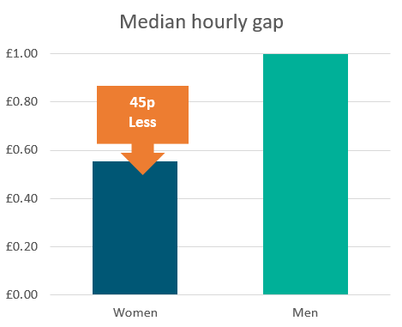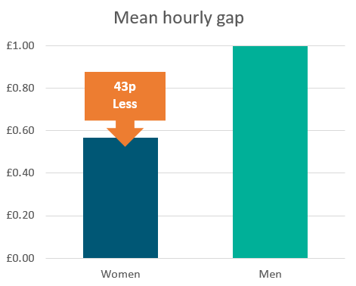

The proportion of women in each pay quartile

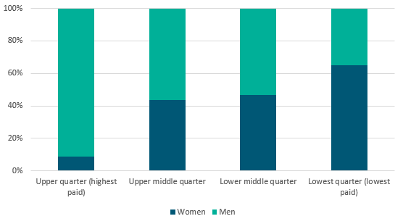At CGWL, women occupy 8.4% of the highest paid jobs and 69.4% of the lowest paid jobs.

About pay quartiles

Pay quartiles are calculated by splitting all employees in an organisation into four even groups according to their level of pay. Looking at the proportion of women in each quartile gives an indication of women’s representation at different levels of the organisation.

Who receives bonus pay?

**•** 85% of women

**•** 90% of men

At CGWL, all permanent employees are eligible to participate in our discretionary bonus scheme. The only employees excluded from this are those on fixed-term contracts or who have yet to pass their probation.

The bonus pay gap

There is a bonus pay gap at CGWL, as women earn 16.5p for every £1 that men earn when comparing median bonus pay, making their median bonus pay 83.5% lower than men’s. When comparing mean bonus pay, women’s mean bonus pay is 86.7% lower than men’s.

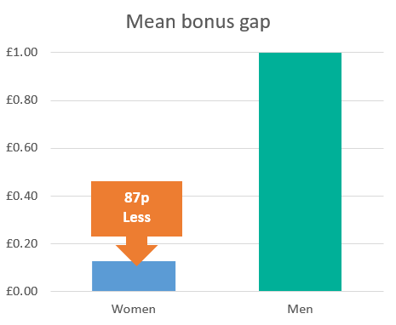

Conclusion

The gender pay gap analysis remains crucial, and we must work diligently to address disparities within Canaccord Wealth.

We encourage women to join us and welcome anyone seeking a fulfilling career. Industry-wide cooperation is essential to ensure equal opportunities for women.

We are committed to nurturing all colleagues and prioritising inclusivity. A diverse workforce enhances business performance and increases satisfaction among colleagues and clients. Our efforts to achieve greater gender parity will continue.